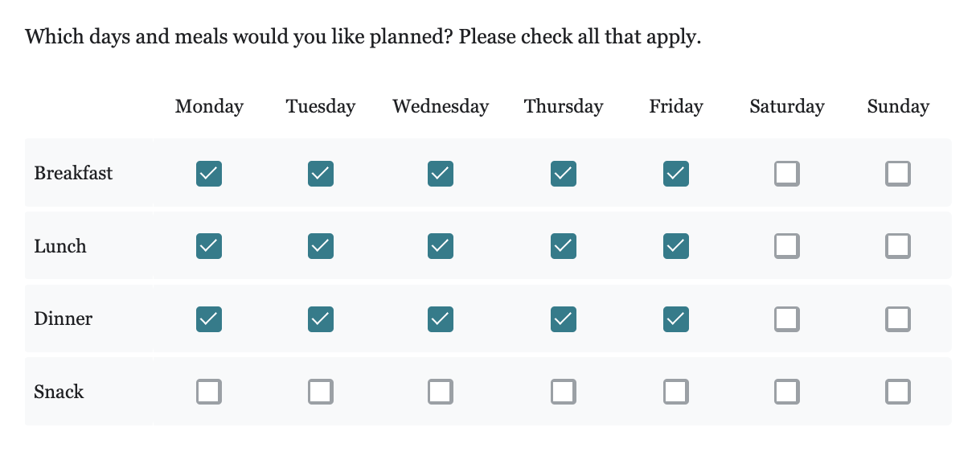

This example shows that the family wants Breakfast, Lunch and Dinner for Monday, Tuesday, Wednesday, Thursday, Friday.